Efficient parallel prefix algorithms on multiport message-passing systems
Yen-Chun Lin , Ching-Sung Yeh

Information Processing Letters 71 (1999) 91–95

Abstract
We present the communication lower bound for the prefix problem on a multiport message-passing fully connected multicomputer. Two efficient parallel prefix algorithms are also presented. Both are optimal in the number of communication steps. One of them is also time-optimal; the other is cost-optimal when 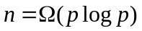, where n is the input size and p < n is the number of processors used.
- Introduction
In a communication step, each PE can send k messages to k other PEs and receive k messages from k PEs, for some k > 1. Such a model, called the k-port model in this paper.

Communication lower bound
Theorem 1. On the k-port model with n PEs, a prefix algorithm needs at least 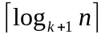 communication steps.

Algorithm A
For example, consider constructing T0 (see Fig. 1) with n = 10 and k = 2 :
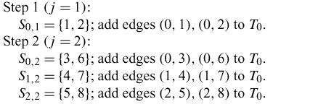
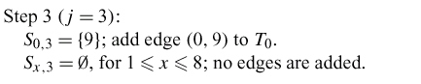
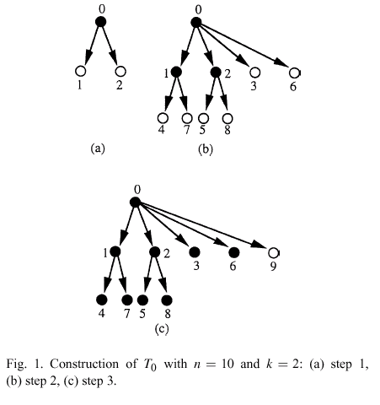
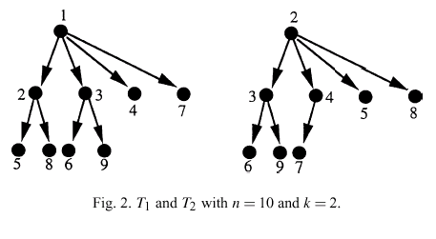
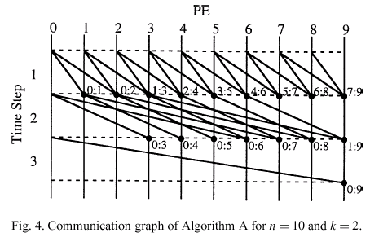
- Algorithm B
we present a parallel prefix algorithm that uses only p < n PEs. The algorithm is based on Algorithm A. Let q = n / p.

Created by : Kuen-Feng Huang
Date : Feb. 9, 2001

